**MIGRATION FROM AZURE DEVOPS TO GITHUB ENTERPRISE**

1. Create a backup of your Azure DevOps repository by creating a zip file of the entire repo.
2. Create a new empty repository on GitHub Enterprise.
3. Create an access key token for read only access in Azure DevOps
   * Go to your profile settings by clicking on your avatar and selecting "Security".

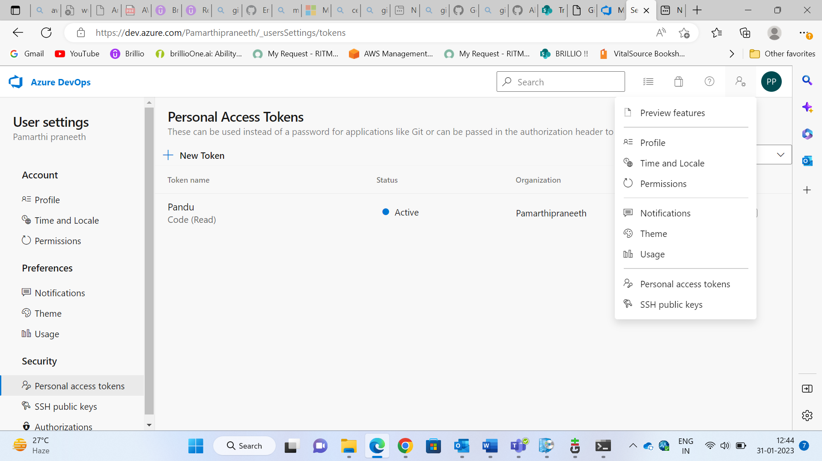

* + Under "Personal access tokens", click on "New Token".
  + Select the “Read” option for code read while creating.

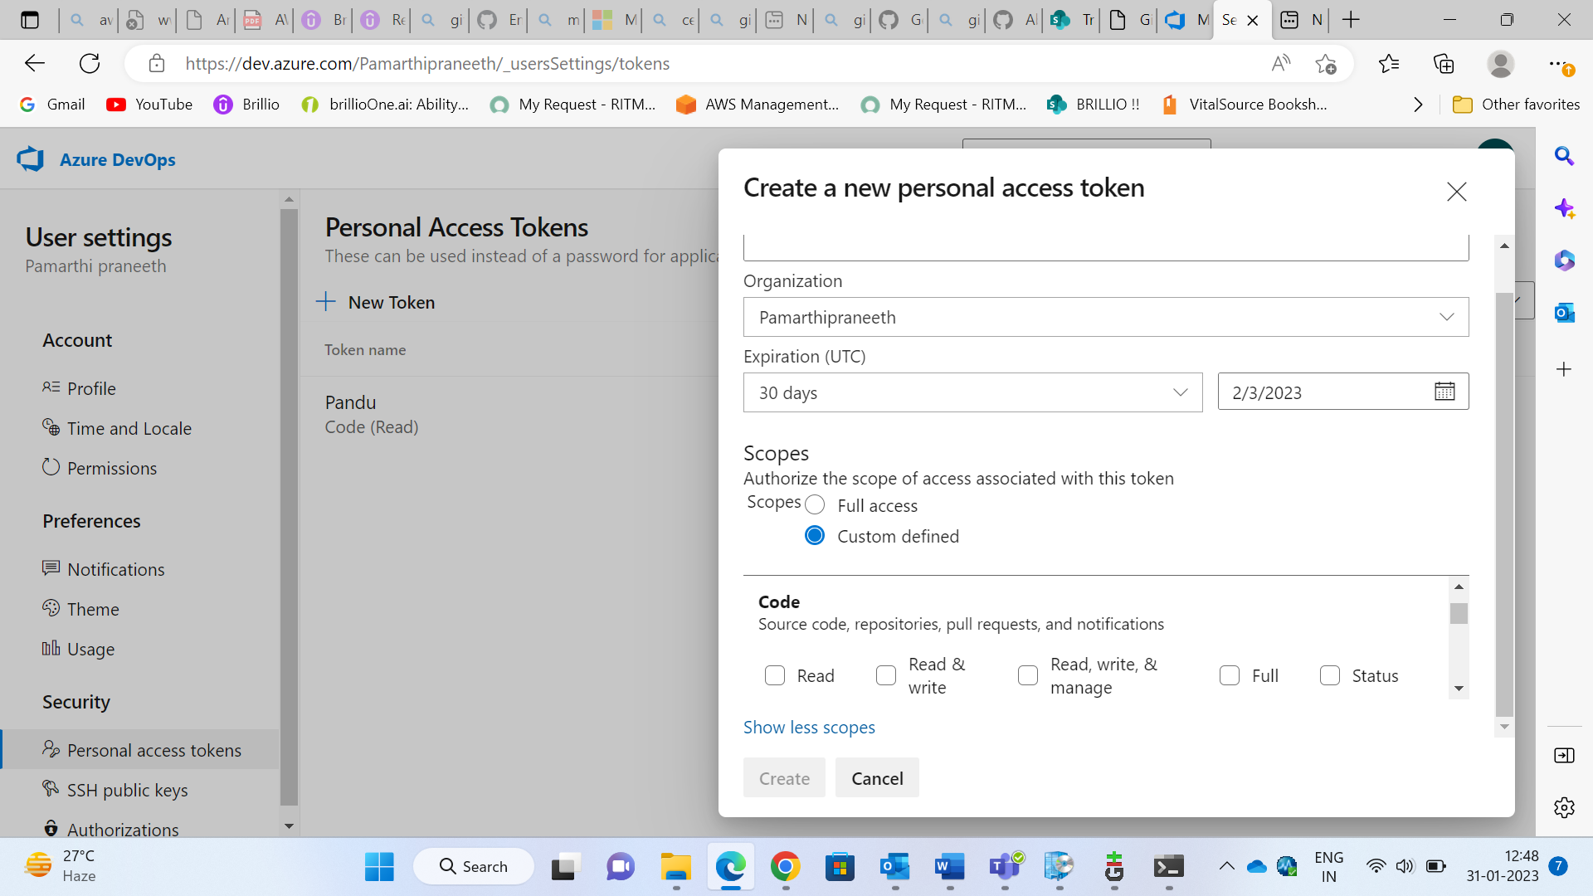

* + Note the access key after generated.

1. Import the Azure DevOps Repository to the GitHub Enterprise Cloud Repository by using import option.

* In the upper-right corner of any page, click , and then click Import repository.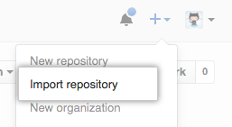
* Under "Your old repository's clone URL", type the URL of the project you want to import.

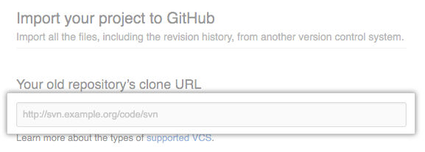

* Choose your personal account or an organization to own the repository, then type a name for the repository on GitHub.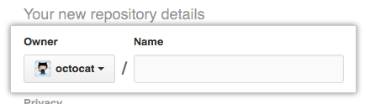
* Specify whether the new repository should be public or private. 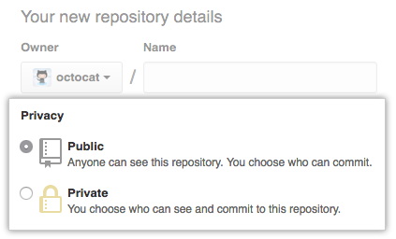
* Review the information you entered, then click Begin import

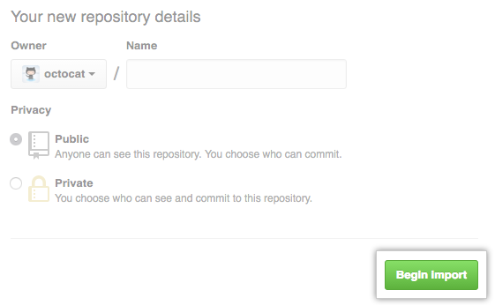

* If your old project requires credentials, type your login information for that project, then click Submit. If SAML SSO or 2FA are enabled for your user account on the old project, enter a personal access token with repository read permissions in the "Password" field instead of your password.

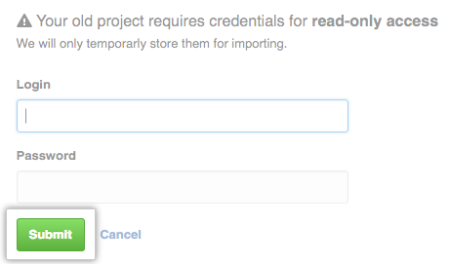

* Note: username – username of the GitHub emu, password - read access key generated.

1. The importer tool will then import all the branches, commits, and pull requests from the Azure DevOps repository into the new GitHub repository.
2. Once the import is complete, verify that all the imported data is correct in the new GitHub repository.
3. Optionally delete the old Azure DevOps repository to avoid confusion.

**REFERNCES**

<https://docs.github.com/en/get-started/importing-your-projects-to-github/importing-source-code-to-github/importing-a-repository-with-github-importer>

<https://github.com/github/gh-gei>Bottom of Form